T1
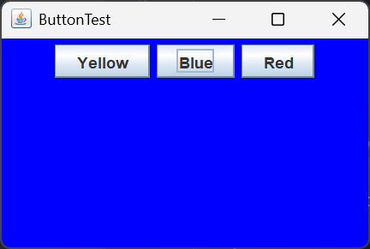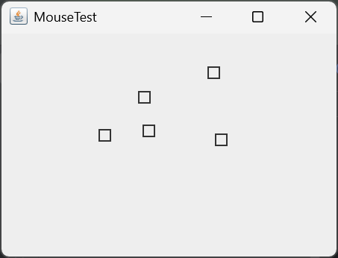
package ink.abalone.week13.T1;

import javax.swing.*;
import java.awt.*;
import java.awt.event.ActionEvent;
import java.awt.event.ActionListener;

public class ButtonFrame extends JFrame {
private JPanel buttonPanel;
private static final int DEFAULT_WIDTH = 300;
private static final int DEFAULT_HEIGHT = 200;
public ButtonFrame() {
setSize(DEFAULT_WIDTH, DEFAULT_HEIGHT);

var yellowButton = new JButton("Yellow");
var blueButton = new JButton("Blue");
var redButton = new JButton("Red");
buttonPanel = new JPanel();
buttonPanel.add(yellowButton);
buttonPanel.add(blueButton);
buttonPanel.add(redButton);
add(buttonPanel);
var yellowAction = new ColorAction(Color.YELLOW);
var blueAction = new ColorAction(Color.BLUE);
var redAction = new ColorAction(Color.RED);
yellowButton.addActionListener(yellowAction);
blueButton.addActionListener(blueAction);
redButton.addActionListener(redAction);
}
private class ColorAction implements ActionListener {
private Color background;
public ColorAction(Color color) {
background = color;
}
@Override
public void actionPerformed(ActionEvent e) {
buttonPanel.setBackground(background);
}
}
}

package ink.abalone.week13.T1;

import javax.swing.*;
import java.awt.*;
import java.awt.event.MouseAdapter;
import java.awt.event.MouseEvent;
import java.awt.event.MouseMotionListener;
import java.awt.geom.Point2D;
import java.awt.geom.Rectangle2D;
import java.util.ArrayList;

public class MouseComponent extends JComponent {
private static final int DEFAULT_WIDTH = 300;
private static final int DEFAULT_HEIGHT = 200;

private static final int SIDELENGTH = 10;
private ArrayList<Rectangle2D> squares;
private Rectangle2D current;
public MouseComponent() {
squares = new ArrayList<>();
current = null;
addMouseListener(new MouseHandler());
addMouseMotionListener(new MouseMotionHandler());
}
public Dimension getPreferredSize() {
return new Dimension(DEFAULT_WIDTH, DEFAULT_HEIGHT);
}
public void paintComponent(Graphics g) {
Graphics2D g2d = (Graphics2D) g;
for (Rectangle2D r : squares) {
g2d.draw(r);
}
}

public Rectangle2D find(Point2D p){
for (Rectangle2D r : squares) {
if (r.contains(p)) return r;
}
return null;
}
public void add(Point2D p) {
double x = p.getX();
double y = p.getY();
current = new Rectangle2D.Double(x-SIDELENGTH/2.0,y-SIDELENGTH/2.0,SIDELENGTH,SIDELENGTH);
squares.add(current);
repaint();
}
public void remove(Rectangle2D s) {
if (s == null)return;
if (s == current)current=null;
squares.remove(s);
repaint();
}
private class MouseHandler extends MouseAdapter {
public void mousePressed(MouseEvent e) {
current = find(e.getPoint());
if (current == null) add(e.getPoint());
}
public void mouseClicked(MouseEvent e) {
current = find(e.getPoint());
if (current != null && e.getClickCount()>=2)remove(current);
}
}
private class MouseMotionHandler implements MouseMotionListener {
@Override
public void mouseDragged(MouseEvent e) {
if (current != null) {
int x = e.getX();
int y = e.getY();
current.setFrame(x-SIDELENGTH/2.0,y-SIDELENGTH/2.0,SIDELENGTH,SIDELENGTH);
repaint();
}
}

@Override
public void mouseMoved(MouseEvent e) {
if (find(e.getPoint())==null)setCursor(Cursor.getDefaultCursor());
else setCursor(Cursor.getPredefinedCursor(Cursor.CROSSHAIR_CURSOR));
}
}
}
T2
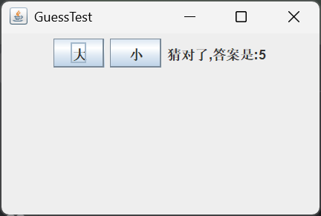
package ink.abalone.week13.T2;

import ink.abalone.week13.T1.ButtonFrame;

import javax.swing.*;
import java.awt.*;
import java.awt.event.ActionEvent;
import java.awt.event.ActionListener;
import java.util.Random;

public class GuessFrame extends JFrame {
private JPanel buttonPanel;
private static final int DEFAULT_WIDTH = 300;
private static final int DEFAULT_HEIGHT = 200;
public GuessFrame() {
setSize(DEFAULT_WIDTH, DEFAULT_HEIGHT);
int guess = new Random().nextInt(0,10);
var large = new JButton("大");
var small = new JButton("小");
buttonPanel = new JPanel();
add(buttonPanel);
large.addActionListener(e -> {
if (guess>=5) buttonPanel.add(new JLabel("猜对了,答案是:"+guess));
else buttonPanel.add(new JLabel("猜错了,答案是:"+guess));
buttonPanel.revalidate();
});
small.addActionListener(e -> {
if (guess<5) buttonPanel.add(new JLabel("猜对了,答案是:"+guess));
else buttonPanel.add(new JLabel("猜错了,答案是:"+guess));
buttonPanel.revalidate();
});
buttonPanel.add(large);
buttonPanel.add(small);
}

public static void main(String[] args) {
EventQueue.invokeLater(() -> {
var frame = new GuessFrame();
frame.setTitle("GuessTest");
frame.setDefaultCloseOperation(JFrame.EXIT_ON_CLOSE);
frame.setVisible(true);
});
}
}

T3
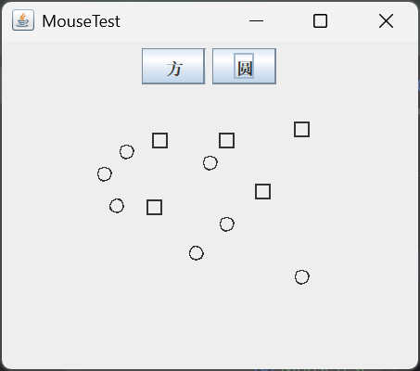
package ink.abalone.week13.T3;

import javax.swing.*;
import java.awt.*;
import java.awt.event.MouseAdapter;
import java.awt.event.MouseEvent;
import java.awt.event.MouseMotionListener;
import java.awt.geom.Ellipse2D;
import java.awt.geom.Point2D;
import java.awt.geom.Rectangle2D;
import java.awt.geom.RectangularShape;
import java.util.ArrayList;

class MouseComponent extends JComponent {
private static final int DEFAULT_WIDTH = 300;
private static final int DEFAULT_HEIGHT = 200;
private static final int SIDELENGTH = 10;
private ArrayList<RectangularShape> squares;
private RectangularShape current;
public boolean isRound = false;
public MouseComponent() {
squares = new ArrayList<>();
current = null;
addMouseListener(new MouseHandler());
addMouseMotionListener(new MouseMotionHandler());
}
public Dimension getPreferredSize() {
return new Dimension(DEFAULT_WIDTH, DEFAULT_HEIGHT);
}
public void paintComponent(Graphics g) {
Graphics2D g2d = (Graphics2D) g;
for (RectangularShape r : squares) {
g2d.draw(r);
}
}
public RectangularShape find(Point2D p){
for (RectangularShape r : squares) {
if (r.contains(p)) return r;
}
return null;
}
public void add(Point2D p) {
double x = p.getX();
double y = p.getY();
if (!isRound){
current = new Rectangle2D.Double(x-SIDELENGTH/2.0,y-SIDELENGTH/2.0,SIDELENGTH,SIDELENGTH);
}else{
current = new Ellipse2D.Double(x-SIDELENGTH/2.0,y-SIDELENGTH/2.0,SIDELENGTH,SIDELENGTH);
}
squares.add(current);
repaint();
}
public void remove(Rectangle2D s) {
if (s == null)return;
if (s == current)current=null;
squares.remove(s);
repaint();
}
private class MouseHandler extends MouseAdapter {
public void mousePressed(MouseEvent e) {
current = find(e.getPoint());
if (current == null) add(e.getPoint());
}
public void mouseClicked(MouseEvent e) {
current = find(e.getPoint());
if (current != null && e.getClickCount()>=2)remove((Rectangle2D) current);
}
}
private class MouseMotionHandler implements MouseMotionListener {
@Override
public void mouseDragged(MouseEvent e) {
if (current != null) {
int x = e.getX();
int y = e.getY();
current.setFrame(x-SIDELENGTH/2.0,y-SIDELENGTH/2.0,SIDELENGTH,SIDELENGTH);
repaint();
}
}
@Override
public void mouseMoved(MouseEvent e) {
if (find(e.getPoint())==null)setCursor(Cursor.getDefaultCursor());
else setCursor(Cursor.getPredefinedCursor(Cursor.CROSSHAIR_CURSOR));
}
}
}

class ButtonPanel extends JPanel {
public ButtonPanel(MouseComponent component) {
var square = new JButton("方");
var round = new JButton("圆");
add(square);
add(round);
square.addActionListener(e-> component.isRound = false);
round.addActionListener(e-> component.isRound = true);
}
}

public class MouseTest extends JFrame {
public MouseTest() {
MouseComponent component = new MouseComponent();
add(new ButtonPanel(component), BorderLayout.NORTH);
add(component, BorderLayout.CENTER);
pack();
}
public static void main(String[] args) {
EventQueue.invokeLater(() -> {
var frame = new MouseTest();
frame.setTitle("MouseTest");
frame.setDefaultCloseOperation(JFrame.EXIT_ON_CLOSE);
frame.setVisible(true);
});
}
}

